1. **Create a virtual network with 2 subnets. Each subnet should have 16 Ips only.**

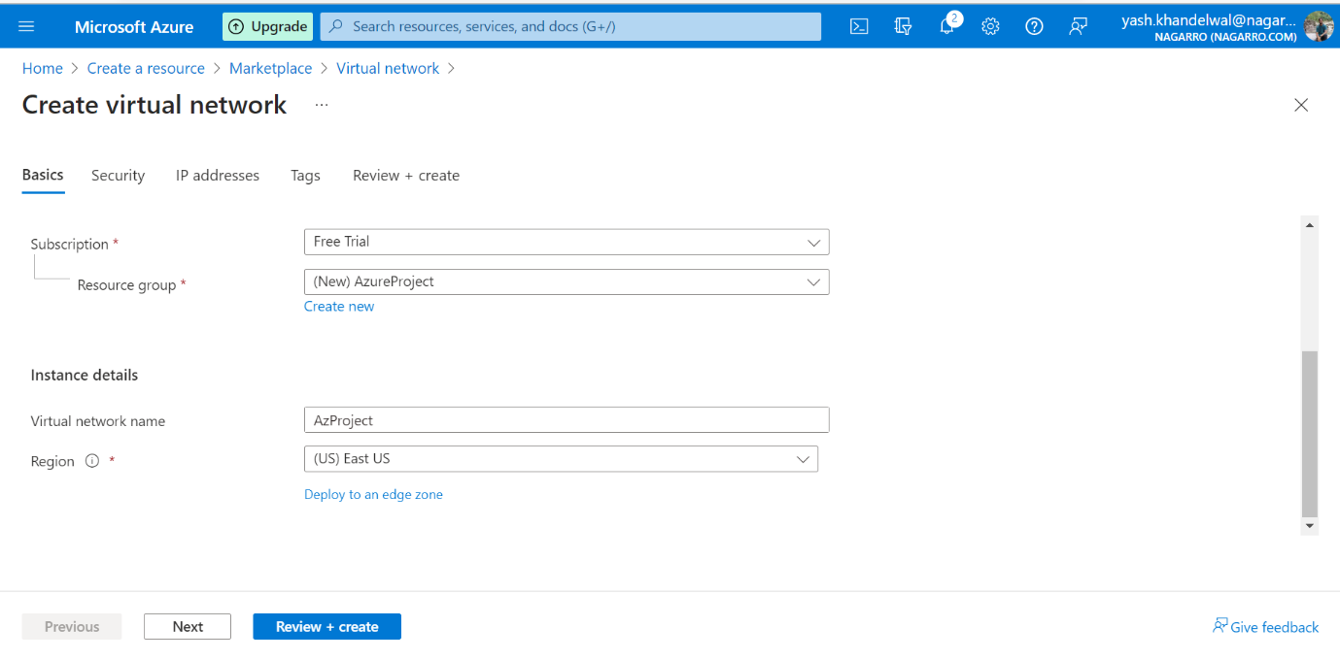

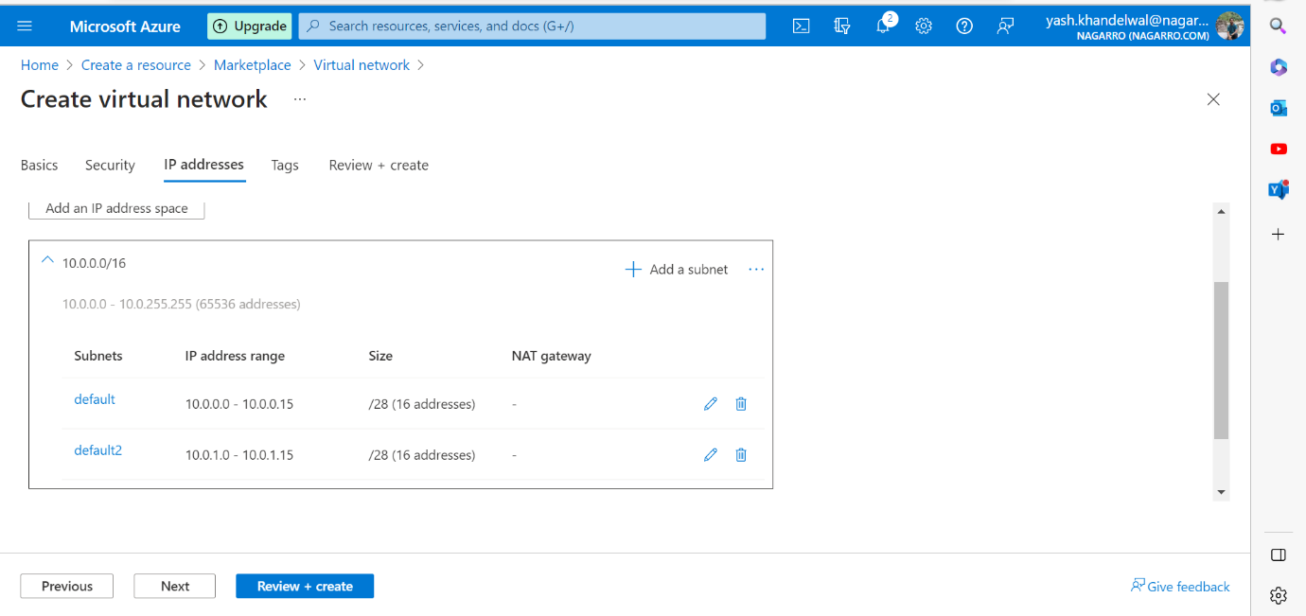

* Edit the default subnet: Within the Virtual Network, create the first subnet. Assign it a CIDR block that allows for 16 IP addresses (e.g., a /28 subnet). A /28 subnet provides 16 IP addresses.

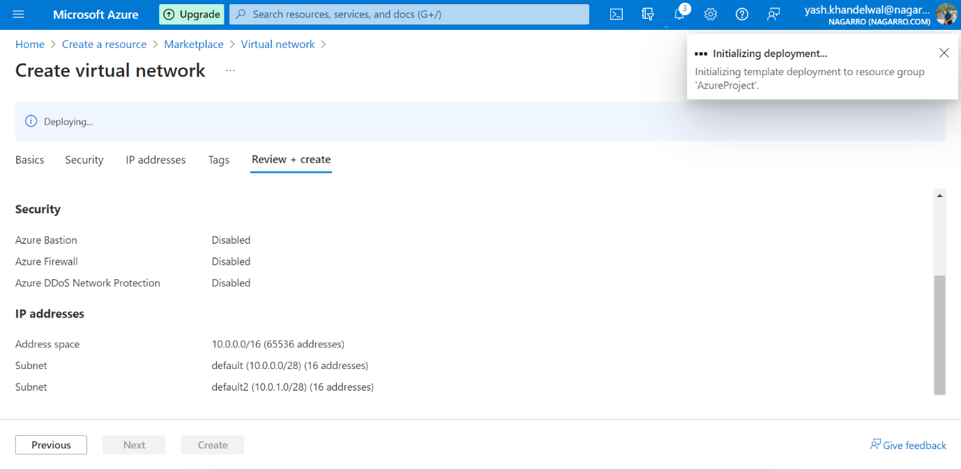

1. **Inside one of the subnets, create a VM and deploy an application code inside it and it should leverage the database on the cloud (any existing application created by you before)**

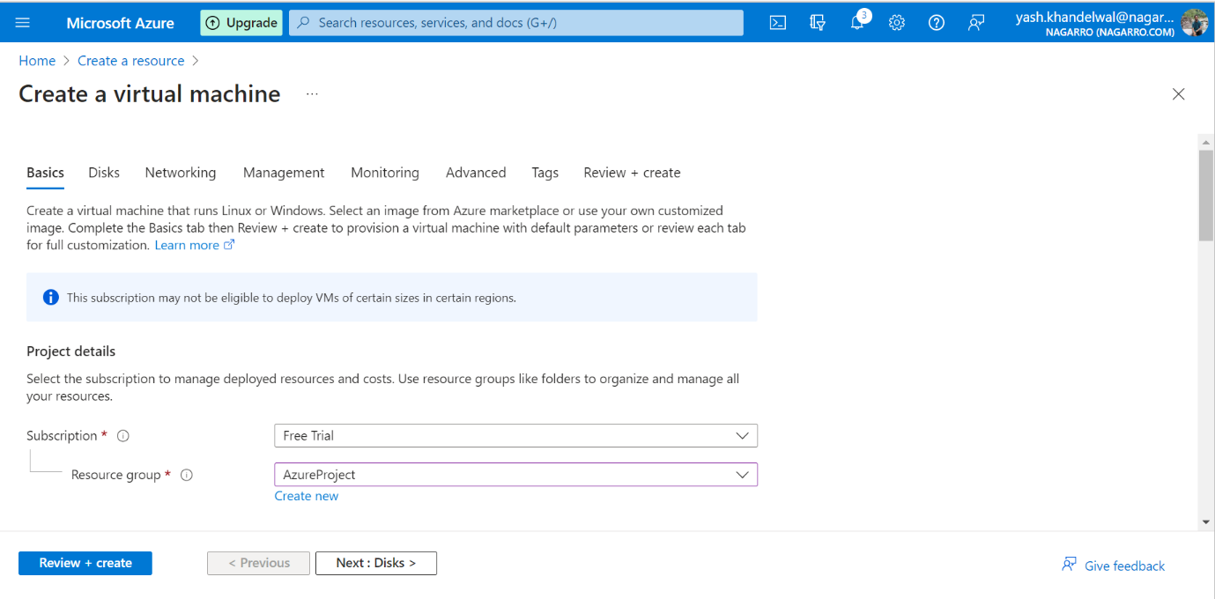

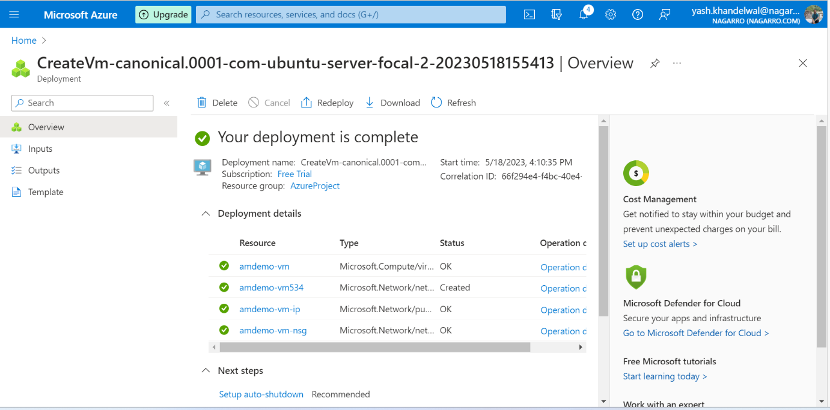

Deploying application code inside virtual machine

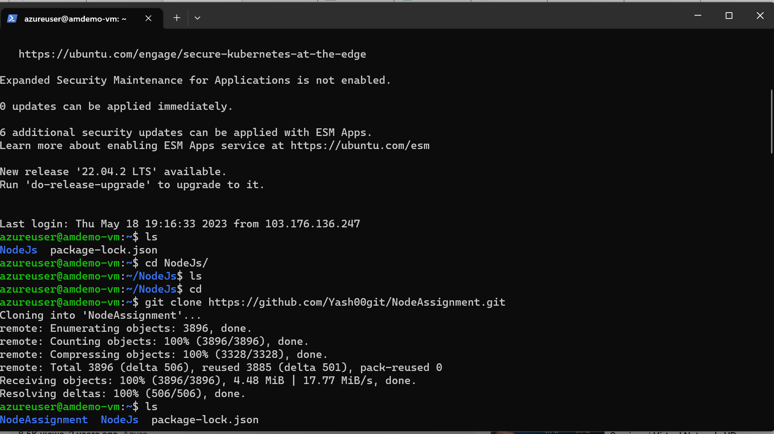

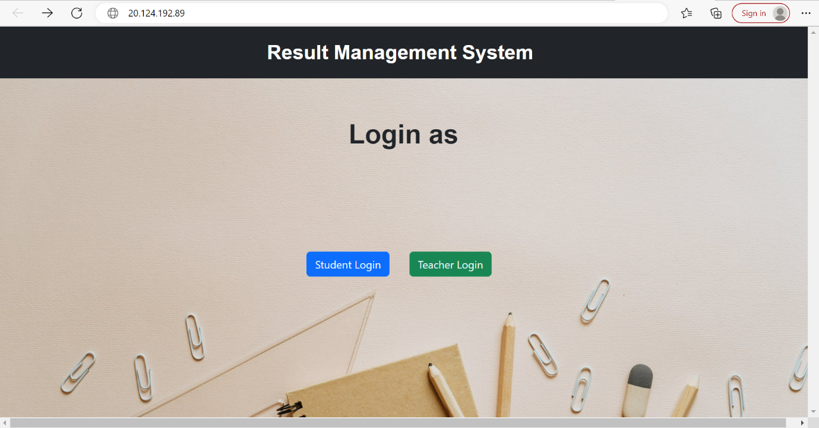

1. **Deploy the same application to Azure App Service. It should also leverage the database on the cloud.**

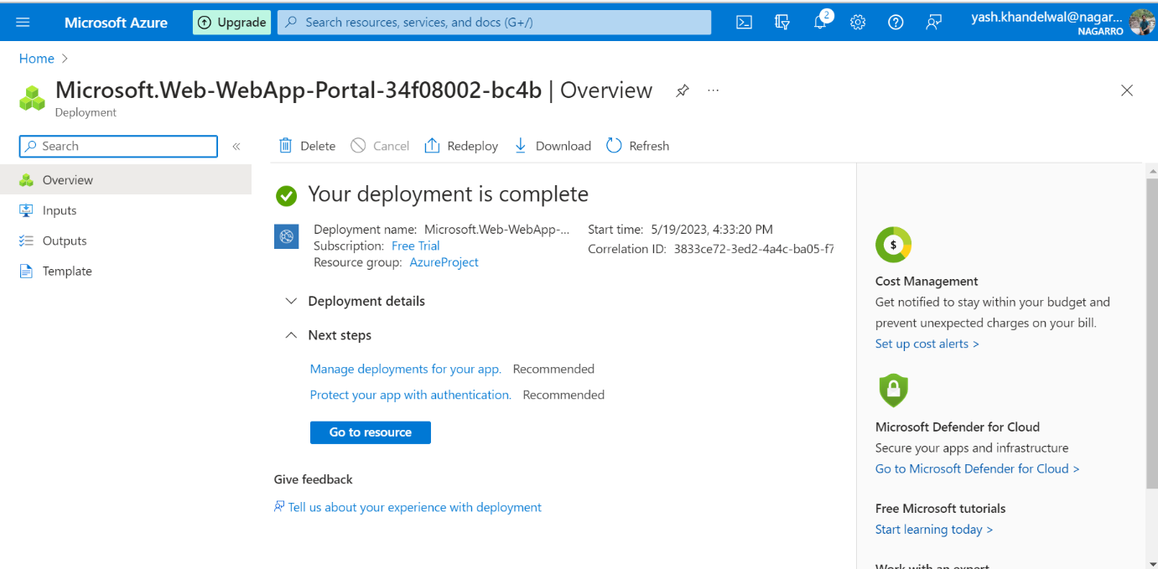

Deploy application to azure app services

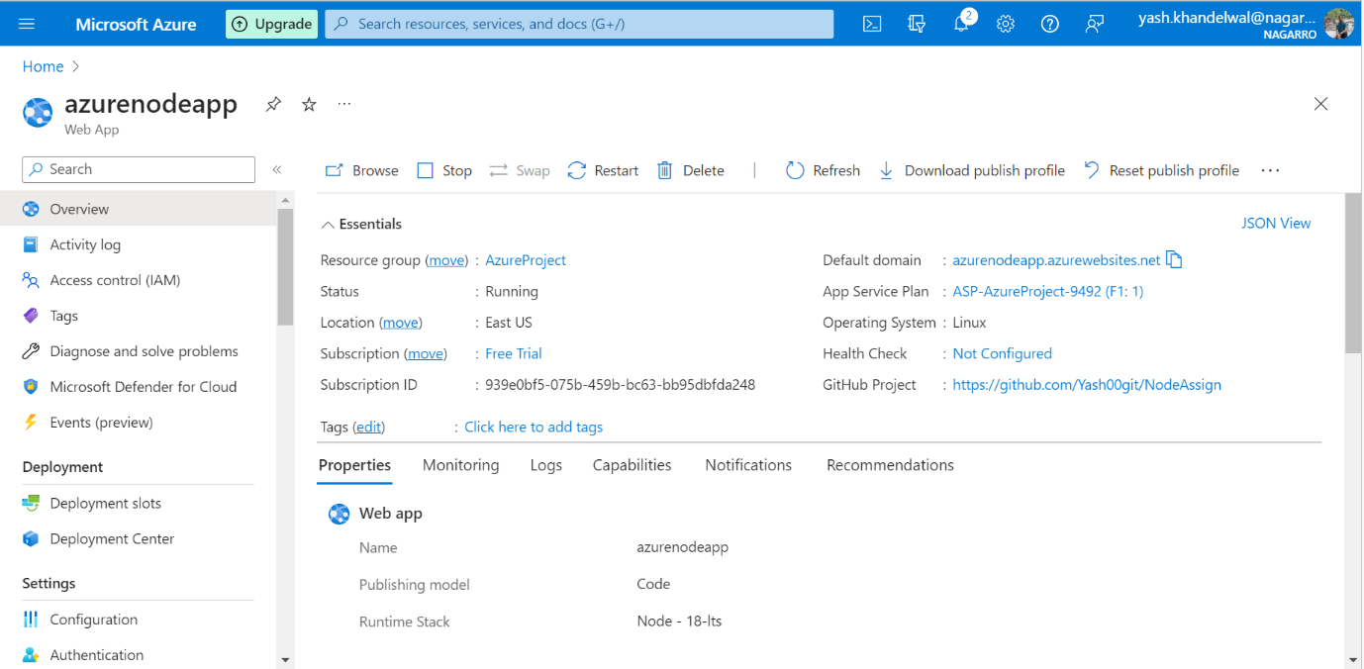

1. **Create the AKS cluster (2 nodes, smallest size VM) and deploy any two services on it. Services should be accessible from the internet.**

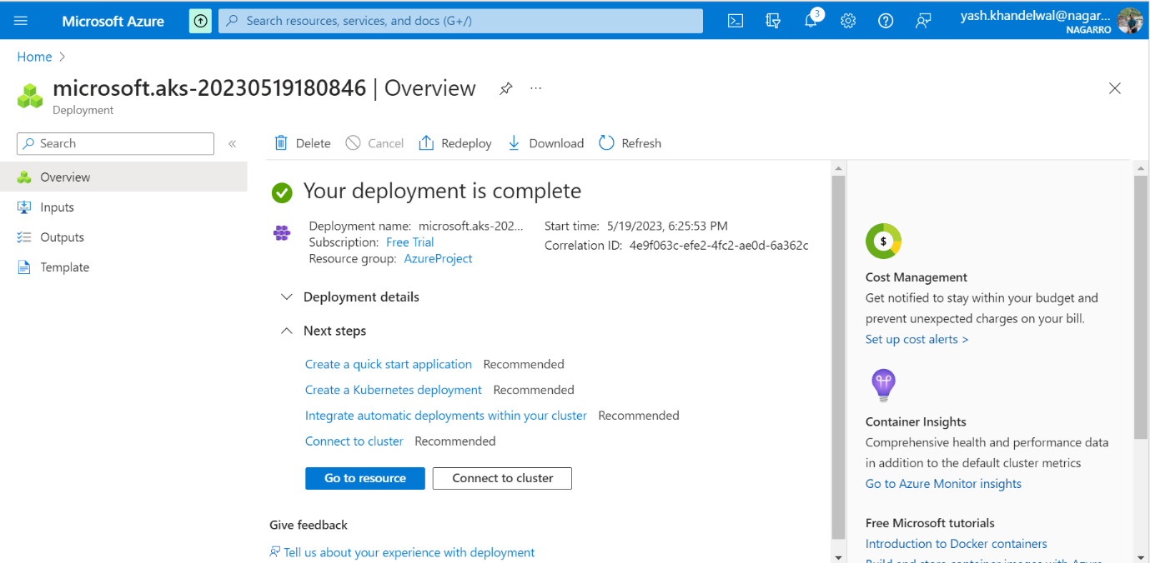

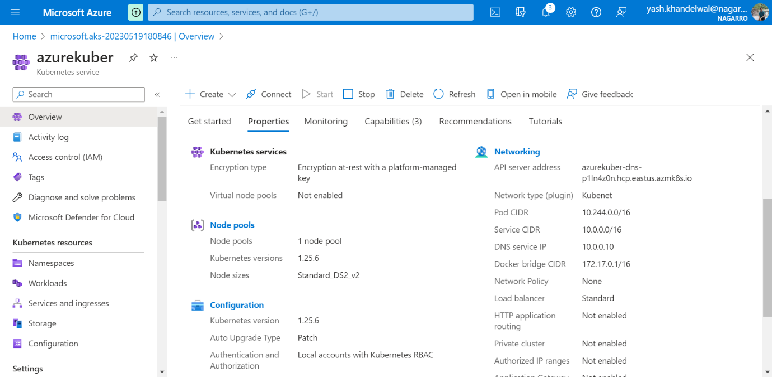

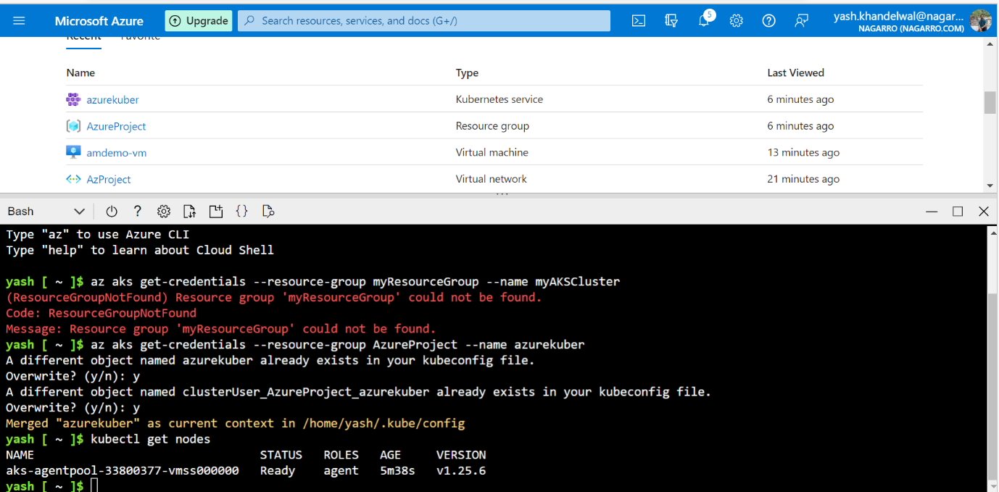

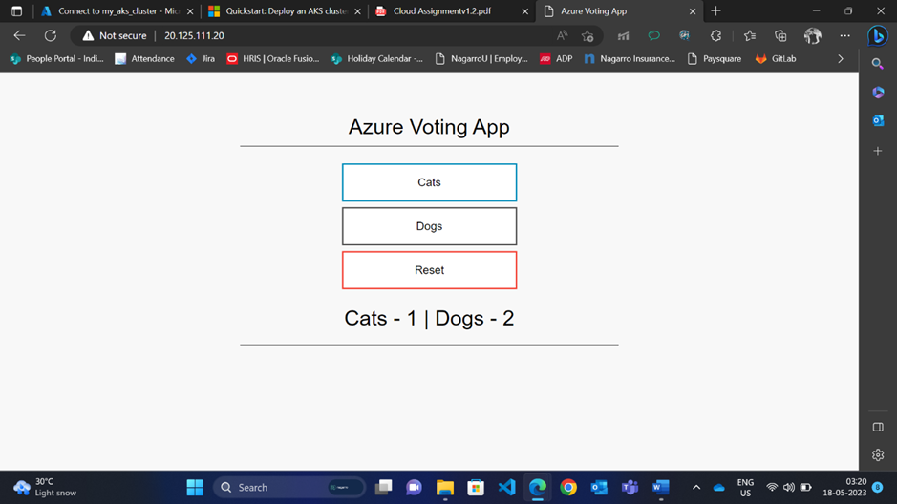

1. **Create an Azure function that should trigger as soon as you upload a file in the blob storage. Function should be able to print the name of the file uploaded in the function.**

Creating storage account

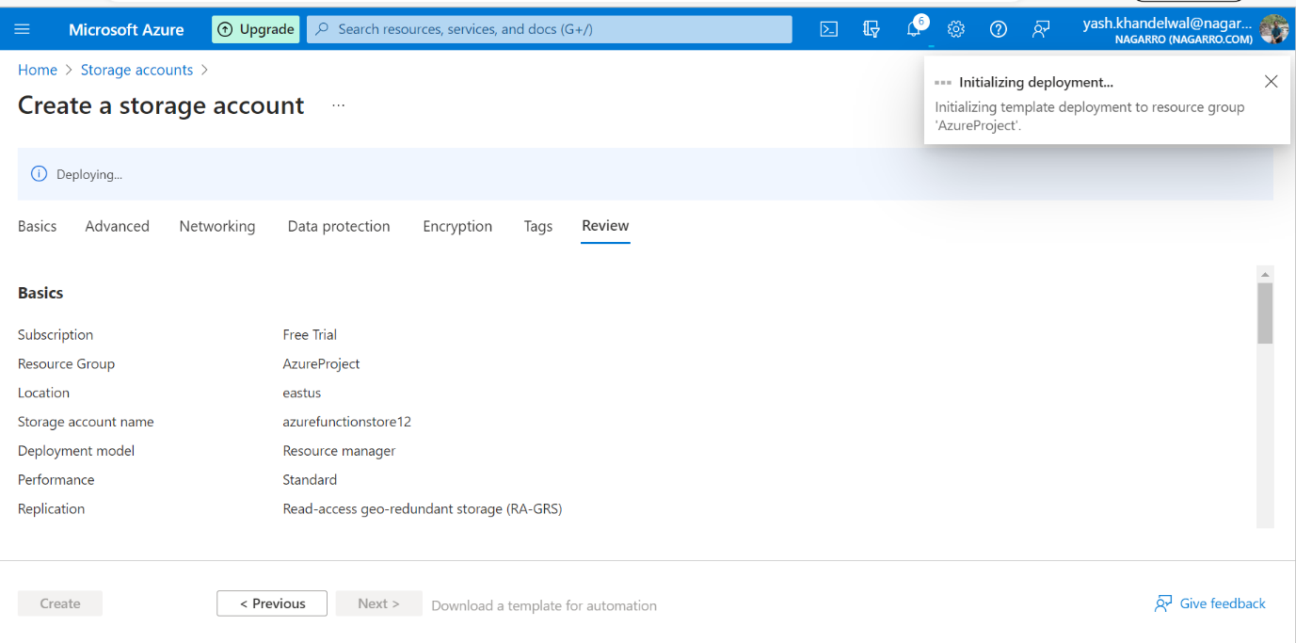

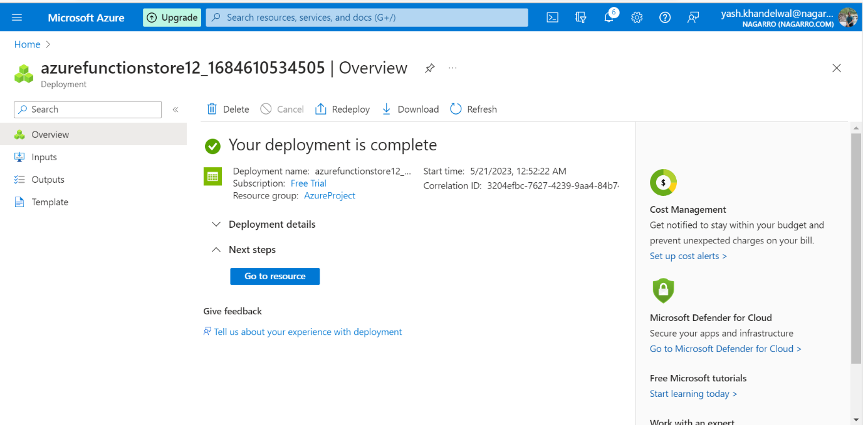

Creating function group

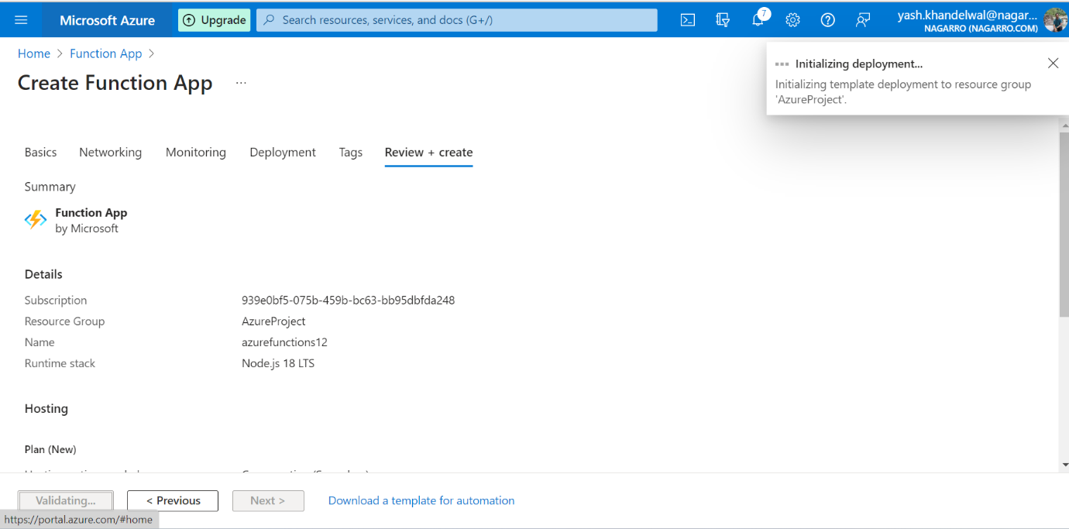

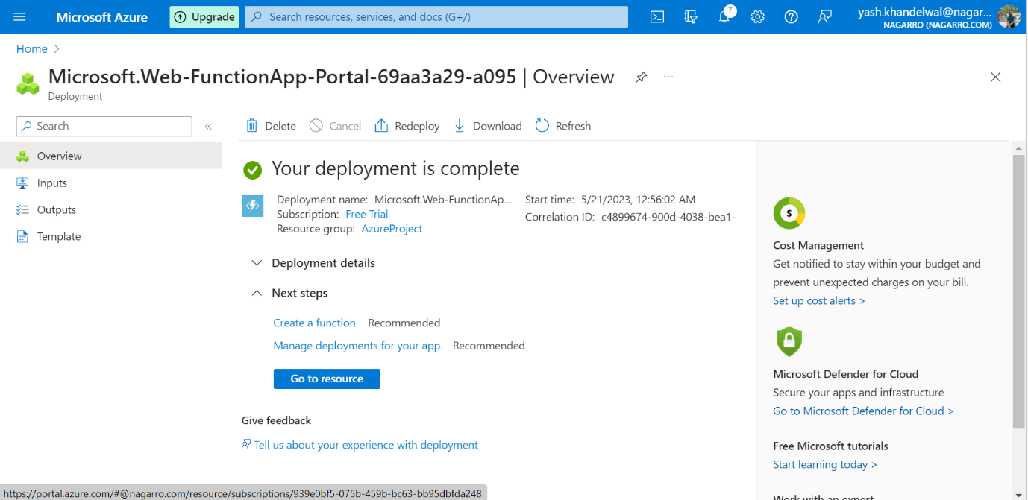

Blob storage account

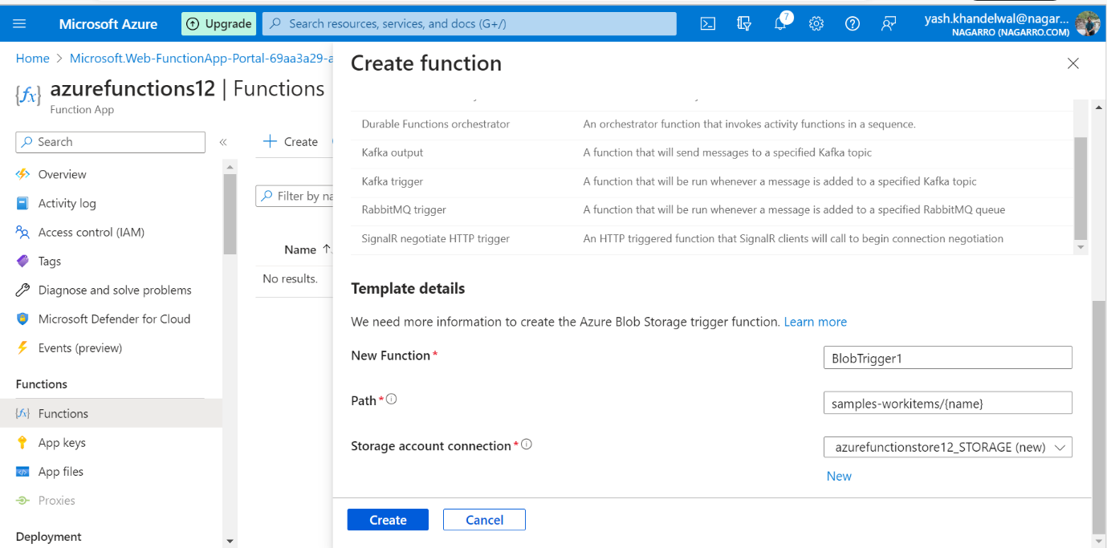

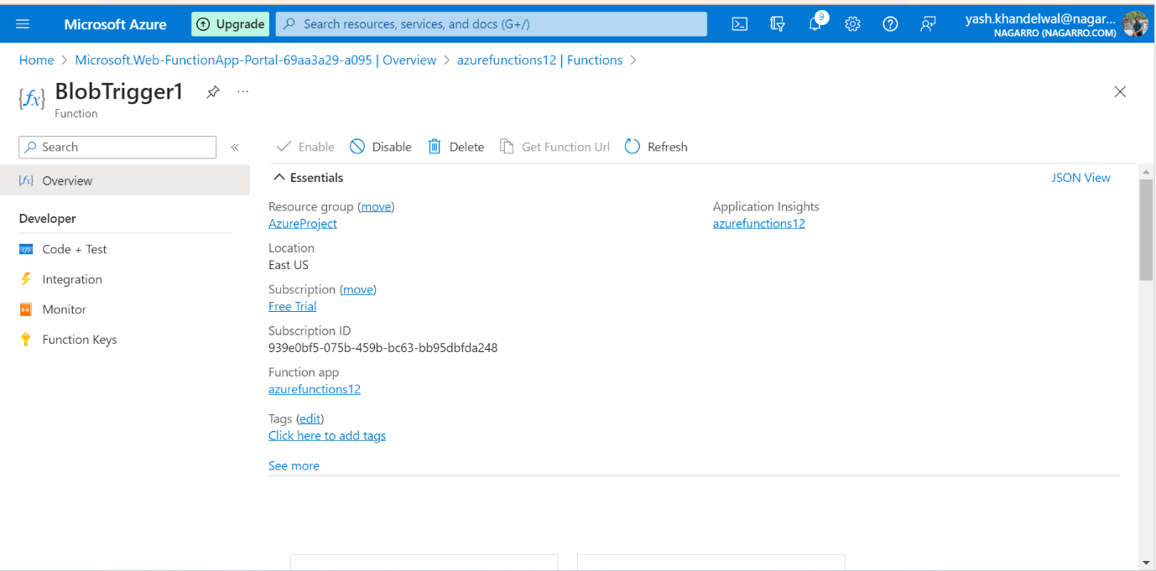

Uploading file to container

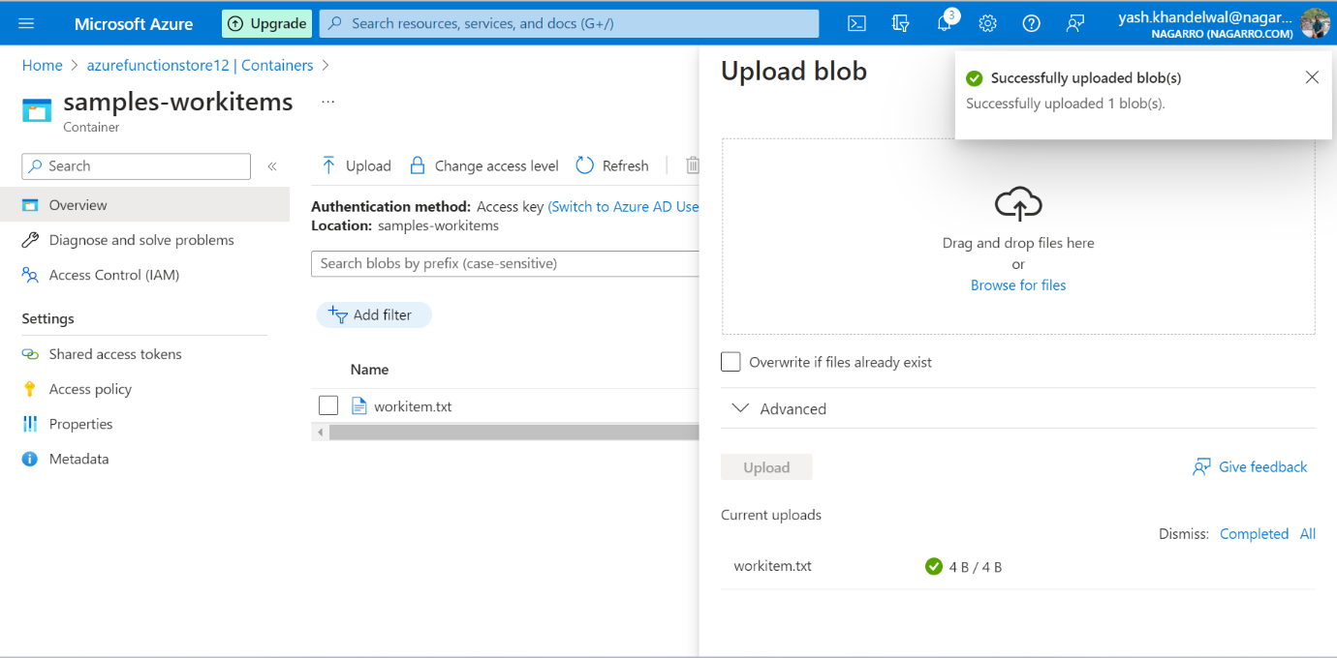

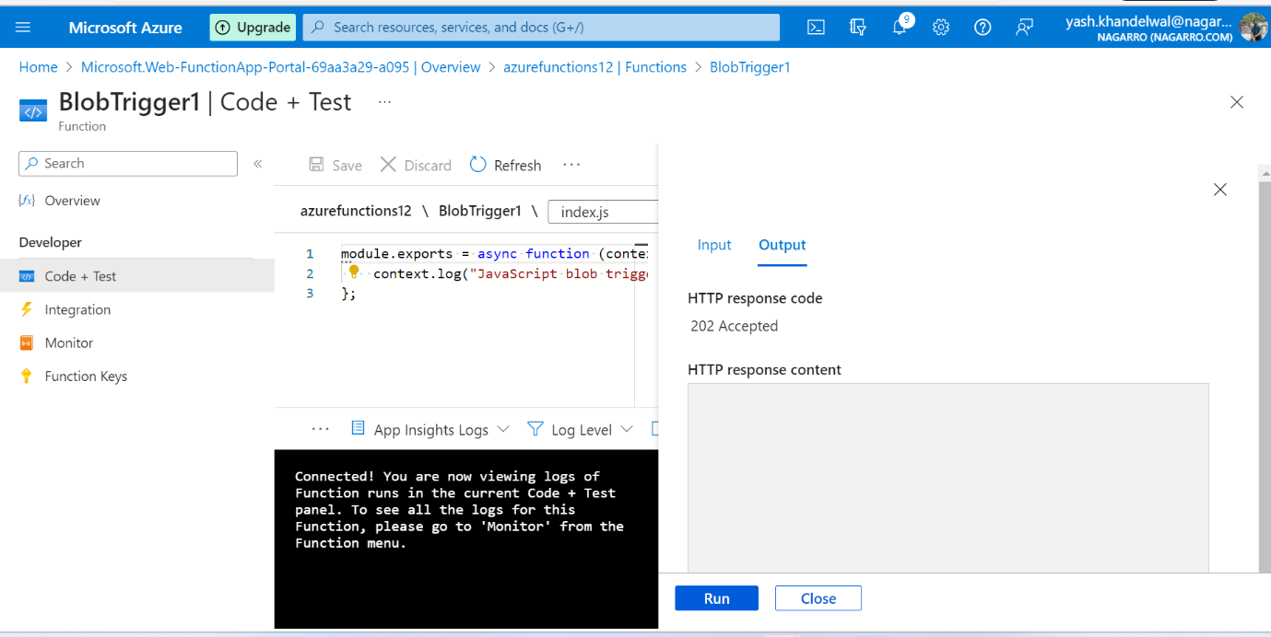

Changing code for printing file name

